Topic 4 Exercise
DBSCAN Clustering
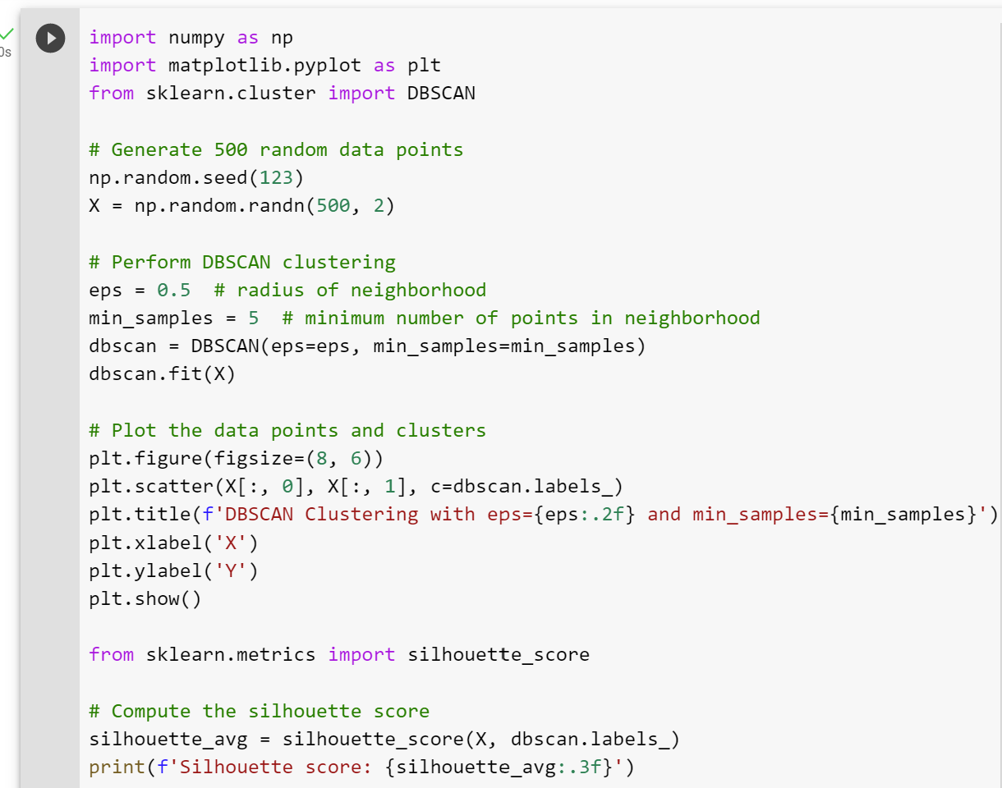
Image from Google Colab by Arden University.

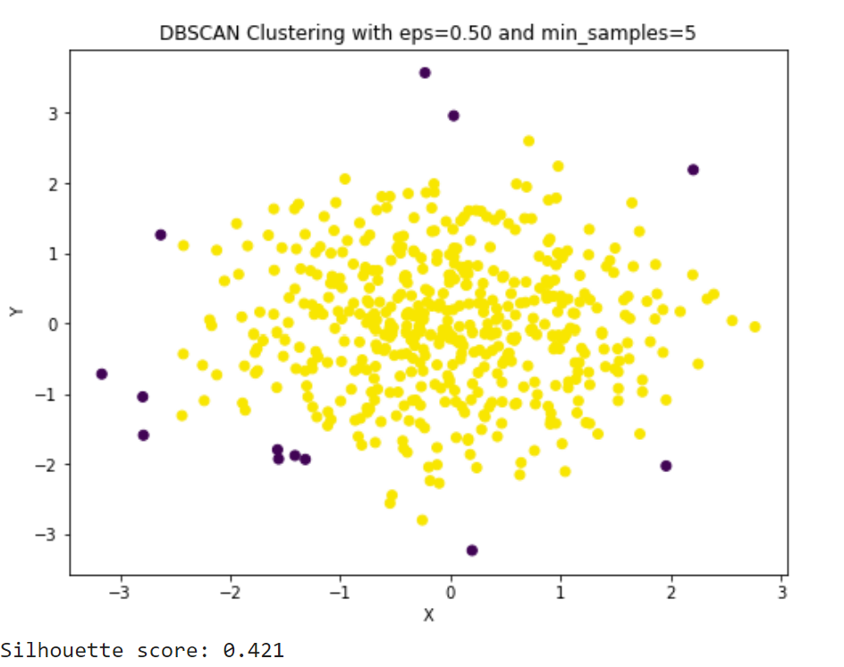
Image from Google Colab by Arden University.

